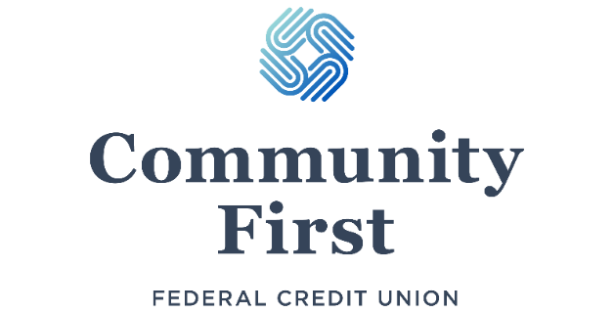
38th Annual Meeting
This year’s Annual Meeting will feature another enjoyable dinner, catered by McKenna’s Village Restaurant, followed by the Credit Union’s business meeting, as well as some wonderful door prizes. If you would like to attend, please apply through our website, OR complete the bottom portion of this form and either return it to one of our four branch locations, or mail it to our main branch:
Community First Federal Credit Union
9637 N Greenville Rd
Lakeview, MI 48850
Date: Tuesday, April 23rd, 2024
Time: 5:45 PM Doors Open; 6:15 PM Dinner; 7:00 PM Meeting
Location: VFW Post 3701 Hall | 506 S Lincoln Ave Lakeview, MI 48850
(Street parking is available along Lincoln Ave., along the north side of the building and in the lot across Lincoln Ave.)
Dinner Menu: Brisket w/ optional Bun, Mac & Cheese, Tossed Salad (Ranch & French), and Green Beans.
Dessert to follow.
Dinner Cost: Adult: $15.00 | Child: $8.00
Meeting Cost: FREE (Please confirm attendance, due to seating limits)

Please RSVP by Monday, April 8th, 2024
_________________________________________________________________

- Name(s) (Required): _________________________________________________________________

- Please reserve me _______ Adult Ticket(s) and _______ Child Ticket(s) for the 38th Annual Meeting of Community First Federal Credit Union.
  - My check for $_______ ($15 per Adult Ticket | $8 per Child Ticket) is enclosed.
OR
- Please deduct $_______ ($15 per Adult Ticket | $8 per Child Ticket) from my (check one):
_______ Regular Shares Account _______ Checking Account _______ Other
Account Number (Required): ______________
- Dietary Restrictions:
  - Please list any dietary restrictions: __________________________________________

Signature (Required): _________________________________________________________________

